An

Industrial Training Report on

# **Front End Web Development**

At

**Bussibees Ed-tech Pvt Ltd**

*Submitted in partial fulfillment of the requirements for the award of the degree of*

**Bachelor of Technology**

## **in**

**Information Technology**



**(Session 2024-25)**

**Submitted to:** **Submitted by:**

Ms. Priya Shekhawat Mayank bhanwara

Mr. Alok Singh PCE23IT029

(Faculty Coordinators)

**DEPARTMENT OF INFORMATION TECHNOLOGY**

**POORNIMA COLLEGE OF ENGINEERING, JAIPUR**

**RAJASTHAN TECHNICAL UNIVERSITY, KOTA**

**August 2024**

## **DECLARATION**

I hereby declare that the work which is being presented in the **Industrial Training** report titled Front-End Web Development in partial fulfillment for the award of the Degree of **Bachelor of Technology** in **Information Technology** and submitted to the Department of **Information Technology**, **Poornima College of Engineering, Jaipur**, is an authentic record of my own work carried out at **Bussibees Ed-tech Pvt Ltd**, Jaipur during the session 2024-25 (Odd Semester).

I have not submitted the matter presented in this report anywhere for the award of any other Degree.

Signature of the Student =>

Name: Mayank bhanwara

Reg. No.: PCE23IT029

Place: Jaipur

Date: 22/08/2024

**TRAINING CERTIFICATE FROM COMPANY**

# 

# **C:\Users\Micro\Downloads\WhatsApp Image 2024-08-22 at 5.37.44 AM(2).jpeg**

# 

# 

# DEPARTMENT OF INFORMATION TECHNLOGY

**Date: 22/08/2024**

CERTIFICATE

This is to certify that **Industrial Training** report on **Front End Web Development** has been submitted by **Mayank bhanwara, PCE23IT029** in partial fulfillment for the award of the Degree of **Bachelor of Technology** in **Information Technology** during the session 2024- 25. The industrial training work is found satisfactory and approved for submission.

**Names and Signatures**

1. **Ms. Priya Shekhawat (Dr. Gajendra Singh Rajawat) Mr. Alok Singh** HOD, IT (Faculty Coordinators – Industrial Training Seminar)

Date: 22/08/2024

Place: Jaipur

# **ACKNOWLEDGEMENT**

I want to express my deep respect and appreciation to my supervisor **Mr. Neeraj Sharma**, who is the HR and Manager of **Bussibees Ed-tech Pvt Ltd**, for his dedicated support, guidance, and encouragement during my internship.

I want to express my sincere thanks to **Mr. Shiryansh Sharma**, Coordinator - Industrial Training, for his cooperation in guiding the topic to its successful conclusion.

I want to express my deep appreciation to **Dr. Gajendra Singh Rajawat**, who is the Head of the Information Technology Department at Poornima College of Engineering, for consistently supporting, guiding, and motivating me throughout this research project.

I appreciate **Dr. Mahesh Bundele**, Director of Poornima College of Engineering, for his helpful attitude and dedication to completing this training work on schedule.

I wish to extend my heartfelt thanks to the leadership of Poornima College of Engineering, which includes **Ar. Rahul Singhi**, Director of Poornima Group, supports the establishment of the institute and the provision of facilities for my education.

I am immensely grateful to my parents and all my other family members for their blessings and motivation. Finally, I want to express my gratitude to God for allowing me to finish my training on schedule.

**Mayank bhanwara**

**PCE23IT029**

# **ABSTRACT**

This report presents a detailed account of a 15-day intensive training program on frontend web development, conducted at First Attempt group in Jaipur. The program commenced with an introduction to HTML, covering

fundamental concepts such as document structure, elements, tags, and attributes. Participants learned to construct well-structured web pages, incorporating various HTML elements to create content-rich and semantically meaningful documents. Emphasis was placed on best practices for writing clean and maintainable code.

Following the HTML module, the training shifted focus to CSS, where participants explored the intricacies of styling web pages. Key topics included selectors, properties, values, and the box model. Advanced CSS techniques such as flexbox, grid layout, and responsive design were also covered, enabling participants to create visually appealing and adaptable web designs.

Throughout the training, hands-on sessions and practical projects were integral components, allowing participants to apply theoretical knowledge to real-world scenarios. These projects included building responsive web pages, implementing complex layouts, and enhancing user interfaces with CSS animations and transitions.

The training concluded with a review of the learning outcomes, highlighting the significant skills and knowledge gained by the participants. Additionally, the report discusses the limitations encountered during the training and provides insights into the future scope of HTML and CSS in the ever-evolving field of web development.

Overall, this training program not only enhanced the technical proficiency of the participants but also instilled a deeper understanding of web development principles, preparing them for further advancements and opportunities in the technology sector.

**TABLE OF CONTENTS**

Contents

**CERTIFICATE** ii

**Company Certificate to be attached** iii

**DECLARATION** iv

**ACKNOWLEDGEMENT** v

**ABSTRACT** vi

**Chapter 1** vii

**Chapter 2** ix

**Chapter 3** xi

**Chapter 4** xvii

**Chapter 5** xix

**Chapter 6** xxi

**REFERENCES** xxiii

# **Chapter 1**

**Introduction**

* 1. **Significance of the training**

The 15-day training on Frontend Web Development at First Attempt Group. was crucial for gaining practical experience in HTML,CSS and JAVA SCRIPT. This training provided hands-on experience in creating responsive and visually appealing web pages, which are essential skills for any aspiring web developer.

**1.2 Company Profile**

My name is Mayank bhanwara, and I am currently pursuing a Bachelor of Technology in Information Technology from Poornima College of Engineering, Jaipur. I am a resident of pratapgarh, Rajasthan. I have a strong passion for technology and web development, which led me to undertake an internship in front-end web development at Bussibees Ed-Tech Pvt. Ltd. This experience has significantly enhanced my technical skills and provided valuable insights into the practical aspects of software development.

**1.2 Training Course:** Front End Web Development

**1.3 Training Platform:** Bussibees Ed-tech Pvt Ltd

**1.4 Training Starting Date:** 11 July 2024

**1.5 Training Ending Date:** 26 July 2024

**1.6 Total Training Duration:** 2 Weeks

**1.7 Date of Certification:** 07 August 2024

**1.3 Introduction to web development**

Web development is the work involved in developing a website for the Internet (World Wide Web) or an intranet (a private network). Web development can range from developing a simple single static page of plain text to complex web applications, electronic businesses, and social network services. A more comprehensive list of tasks to which Web development commonly refers, may include Web-engineering, Web-design, Web content development, client liaison, client-side/server-side scripting, Web server and network security configuration, and e-commerce development. For larger organizations and businesses, Web development teams can consist of hundreds of people (Web-developers) and follow standard methods like agile methodologies while developing Web sites. Smaller organizations may only require a single permanent or contracting developer, or secondary assignment to related job positions such as a graphic designer or information systems technician. Web-development may be a collaborative effort between departments rather than the domain of a designated department. There are three kinds of Web developer specialization: front-end-developer, back-end-developer, and full-stack-developer. Front-end developers are responsible for behaviour and visuals that run in the user browser, while back-end developers deal with the servers.

**1.2 Several Aspects of Web-Development**

Before developing a website once should keep several aspects in mind like:

⮚ What to put on the website?

⮚ Who will host it?

⮚ How to make it interactive?

⮚ How to secure the source code frequently?

⮚ Will the website design display well in different browsers?

⮚ Will the navigation men us be easy to use?

⮚ Will the website load quickly?

⮚ How easily will the site pages print?

**CHAPTER-2**

**Technology Specification**

**2.1 Language Learned**

During the training, the primary languages learned were HTML and CSS. These languages are fundamental for frontend web development, allowing the creation of structured and styled web pages.

**2.2 Tools or Company Technology**

The training involved using various tools and technologies, including:

* **Text Editors:** Visual Studio Code(VS code)
* **Browsers:** Google Chrome, for testing and debugging

**2.3 Hardware Requirement**

TABLE1- Hardware requirement

|  |  |
| --- | --- |
| **Number** | **Description** |
| 1 | 64 bit Architecture Window11 |
| 2 | 4GB RAM |

**2.4 Software Required:**

TABLE2- Software requirement

|  |  |
| --- | --- |
| **Number** | **Description** |
| 1 | Windows 11 2. 3. 4. Server |
| 2 | API |
| 3 | Server |
| 4 | HTML/CSS/BASIC JavaScript |

**2.5 Tool description**

The Translate and Edit application had been planned to consist of two parts-front-end and back end-development. The front-end is the part of the web that you can see and interact with (e.g., Client-side programming). While front-end code interacts with the user in real time, the back-end interacts with a server to return user ready results. The front-end is a combination of HTML, CSS and JavaScript coding. By using JavaScript, modifications of the design of a web page can be made immediately, however only temporary and visible only by the user. Normally the user would not have rights to modify web content dynamically on the server side. Logically, administrators are the ones who deal with back-end modification of databases for example, as they often contain sensitive data which should not be available to see or modify by the general public. These front-end and back-end tools includes languages like HTML, CSS, JavaScript etc. We will discuss all these languages in brief as given below.

**2.6 Features**

* Web Page Assets
* Resources
* Network Information
* Profiting and Auditing

**CHAPTER- 3**

**Project Description/Technology Learned Description**

The training project involved creating a responsive website for a fictional healthcare service. The project included:

* HTML: Structuring the content with semantic elements like headers, footers, sections, and articles.
* CSS: Styling the website using CSS properties, including flexbox and grid for layout, and media queries for responsiveness.
* JAVA SCRICPT: JavaScript is a dynamic programming language used for creating interactive web pages, enabling features like animations and real-time updates. It powers both client-side and server-side development, making it essential for modern web development.

**3.1 Introduction to HTML**

The Hyper Text Markup Language or HTML is the standard markup language for documents designed to be displayed in a web browser. It can be assisted by technologies such as Cascading Style Sheets (CSS) and scripting languages such as JavaScript. Web browsers receive HTML documents from a web server or from local storage and render the documents into multimedia web pages. HTML describes the structure of a web pages semantically and originally included cues for the appearance of the document. HTML elements are the building blocks of HTML pages. With HTML constructs, images and other objects such as interactive forms may be embedded into the rendered page. HTML provide same and to create structured documents by denoting structural semantics for text such as headings, paragraphs, lists, links, quotes and other items. HTML elements are delineated by tags, written using angle brackets. Tags such as **<img>** and **<input>** directly introduce content into the page. Other tags such as **<p>** surround and provide information about document text and may include other tags as sub-elements. Browsers do not display the HTML tags but use to interpret the content of the page.

**3.2 What is the Web?**

The Web is composed of web pages stored on web servers, which are machines that are constantly connected to the Internet and which provide the pages that users request. Every webpage, and more generally any online resource, such as images, video, music, and animation, is associated with a unique address called a URL. The key element for viewing web pages is the browser, a software program which sends requests to web servers, then processes the resulting data and displays the information as intended, based on instructions in the HTML page. The most commonly used browsers on the Internet include:

1. Mozilla Firefox,

2. Microsoft Internet Explorer,

3. Netscape Navigator,

4. Safari,

5. Opera

6. Chrome

**3.3 Versions of HTML**

HTML was designed by Tim Berners-Lee, at the time a researcher at CERN (Chinese Ecosystem Research Network), beginning in 1989. He officially announced the creation of the Web on Usenet in August 1991. However, it wasn't until 1993 that HTML was considered advanced enough to call it a language (HTML was then symbolically christened HTML 1.0). RFC1866, dated November1995, represented the first official version of HTML, called HTML 2.0. After the brief appearance of HTML 3.0, which was never officially released, HTML 3.2 became the official standard on January 14, 1997. The most significant changes to HTML 3.2 were the standardization of tables, as well as many features relating to the presentation of web pages.

On December 18, 1997, HTML 4.0 was released. Version 4.0 of HTML was notable for standardizing style sheets and frames. HTMLversion4.01, which came out on December 24, 1999 , made several minor modifications to HTML4.0.

**Example:**

<!DOCTYPE html>

<html lang="en">

<head>

    <meta charset="UTF-8">

    <meta name="viewport" content="width=device-width, initial-scale=1.0">

    <title>Document</title>

</head>

<body>

</body>

</html>

**3.4 What is CSS?**

**Cascading Style Sheets (CSS)** is a style sheet language used for describing the presentation of a document written in a markup language such as HTML. CSS is a corner stone technology of The World Wide Web, along side HTML and JavaScript.

CSS is designed to enable the separation of presentation and content, including layout, colors, and fonts. This separation can improve content accessibility; provide more flexibility and control in the specification of presentation characteristics; enable multiple web pages to share formatting by specifying the relevant CSS in a separate **.css file**, which reduces complexity and repetition in the structural content; and enable the .css file to be cached to improve the page load speed between the pages that share the file and its formatting.

The name **cascading** comes from the specified priority scheme to determine which style rule applies if more than one rule matches a particular element. This cascading priority scheme is predictable.

**3.5 CSS Syntax:**

A CSS rule-set consists of a selector and a declaration block.

CSS selector: The selector points to the HTML element you want to style.

The declaration block contains one or more declarations separated by semicolons. Each declaration includes a CSS property name and a value, separated by a colon.

A CSS declaration always ends with a semicolon, and declaration blocks are surrounded by curly braces.

The External CS Scan be declared in the required HTML pages:

<link rel="stylesheet" href="">

The External CSS file is saved by using the .css extension, whereas the internal CSS is saved in corresponding HTML file using the <style> tag. Using External CSS is much better than using Internal. Here are a few reasons this is better.

⮚ Easier Maintenance

⮚ Reduced File Size

⮚ Reduced Bandwidth

⮚ Improved Flexibility

The selectors that can be used to select the HTML part are-

⮚ Id selector

⮚ Class selector

**3.5.1 : Id-Selector**

The id selector uses the id attribute of an HTML element to select a specific element. The id of an element should be unique within a page, so the id selector is used to select one unique element with a specific id, write a hash (#) character, followed by the id of the element. The style rule below will be applied to the HTML element with id=”para-1”:

Example:

Suppose the HTML content is as follow,

<h1 id=”para-1”> content </h1>. Then Id will be declared as #para1

{

text-align: center ; color:blue;

font-family:

}

**3.5.2 The class Selector:**

The class selector selects elements with a specific class attribute.

To select elements with a specific class, write a period() character, followed by the name of the class.

**Example:**

.para-1

{

Text-align: center: color: blue:

Font-family: ;

}

**NOTE:**

* We can access class in style page or in HTML page as well by using style tag in head tag.
* Class makes our work easy as we can give many tags a single attributes by using class name and assign the same to the setags.
* Class scan be access by(.) dot operator in style or CSS file.

**3.6 CSS Comments:**

Comments are used to explain the code, and may help when you edit the source code at a later date. Comments are ignored by browsers. A CSS comment starts with /* and endswith */. Comment scan also span multiple lines.

**Example:**

.para-1

{

text-align: center; color: blue;

font-family; /*this is the single line comment*/

}

In the example above, all HTML elements with class = para-l will be blue and center-aligned**.**

**3.7 CSS Styles:**

⮚ Background properties

⮚ Border properties

⮚ Padding

⮚ Margin

⮚ Colour

⮚ Font properties

⮚ Text properties Link properties/Navigation bar propertie

**3.8 JAVA SCRIPT**

JavaScript is a high-level, dynamic programming language primarily used to create interactive effects within web browsers. Here's an overview:

**1. Introduction**

- Type: Interpreted, dynamic, and weakly typed.

- Paradigm: Multi-paradigm (supports event-driven, functional, and imperative programming styles).

- First Released: December 4, 1995.

- Created by: Brendan Eich at Netscape.

- Standardized: ECMAScript (ECMA-262).

**2. Key Features**

- Client-Side Execution: JavaScript code is executed on the user's browser, reducing server load and providing real-time interactivity.

- Asynchronous Programming: JavaScript supports asynchronous operations using callbacks, promises, and async/await, allowing for non-blocking operations.

- Event-Driven: JavaScript can react to user actions, such as clicks, form submissions, and key presses.

- DOM Manipulation: JavaScript allows dynamic interaction with the HTML document structure (DOM), enabling updates to the page content without reloading.

- Platform-Independent: JavaScript runs on any device with a browser, making it highly portable.

- Prototypal Inheritance: Unlike classical inheritance, JavaScript uses prototypes, which allows objects to inherit directly from other objects.

**3. Usage**

- Web Development: JavaScript is the backbone of web development, responsible for client-side interactivity.

- Server-Side Development: With Node.js, JavaScript is also used for server-side programming.

- Mobile Development: Frameworks like React Native allow developers to create mobile applications using JavaScript.

- Game Development: Libraries like Phaser and Babylon.js enable JavaScript for 2D and 3D game development.

- Desktop Applications: Electron enables the development of cross-platform desktop applications using JavaScript.

**4. Popular Frameworks and Libraries**

- React: A JavaScript library for building user interfaces, particularly single-page applications.

- Angular: A platform for building mobile and desktop web applications.

- Vue.js: A progressive JavaScript framework for building user interfaces.

- jQuery: A fast, small, and feature-rich JavaScript library that simplifies HTML document traversal and manipulation.

- Node.js: A runtime environment that allows JavaScript to be run on the server-side.

**5. Modern JavaScript (ES6 and beyond)**

- Arrow Functions: Shorter syntax for writing functions.

- Template Literals: Allows for multi-line strings and string interpolation.

- Let and Const: Block-scoped variable declarations.

- Modules: Enables modular code by importing/exporting functions or variables between files.

- Promises: Improves the handling of asynchronous operations.

- Classes: Introduces a more straightforward syntax for creating objects and handling inheritance.

**6. Challenges**

- Browser Compatibility: Although standardized, not all browsers interpret JavaScript the same way.

- Security: As JavaScript runs on the client side, it is susceptible to security risks like cross-site scripting (XSS).

- Performance: Heavy reliance on JavaScript can slow down web pages if not optimized properly.

**7. Future of JavaScript**

- WebAssembly: A binary instruction format that could supplement JavaScript in the browser for performance-critical applications.

- Evolution: JavaScript continues to evolve with annual ECMAScript updates introducing new features and syntax improvements.

JavaScript is one of the most versatile and widely-used programming languages, central to modern web development and increasingly important in other domains.

**CHAPTER-4**

**Project Snapshots**

**4.1 Project Snapshots**

Image1-Homepage

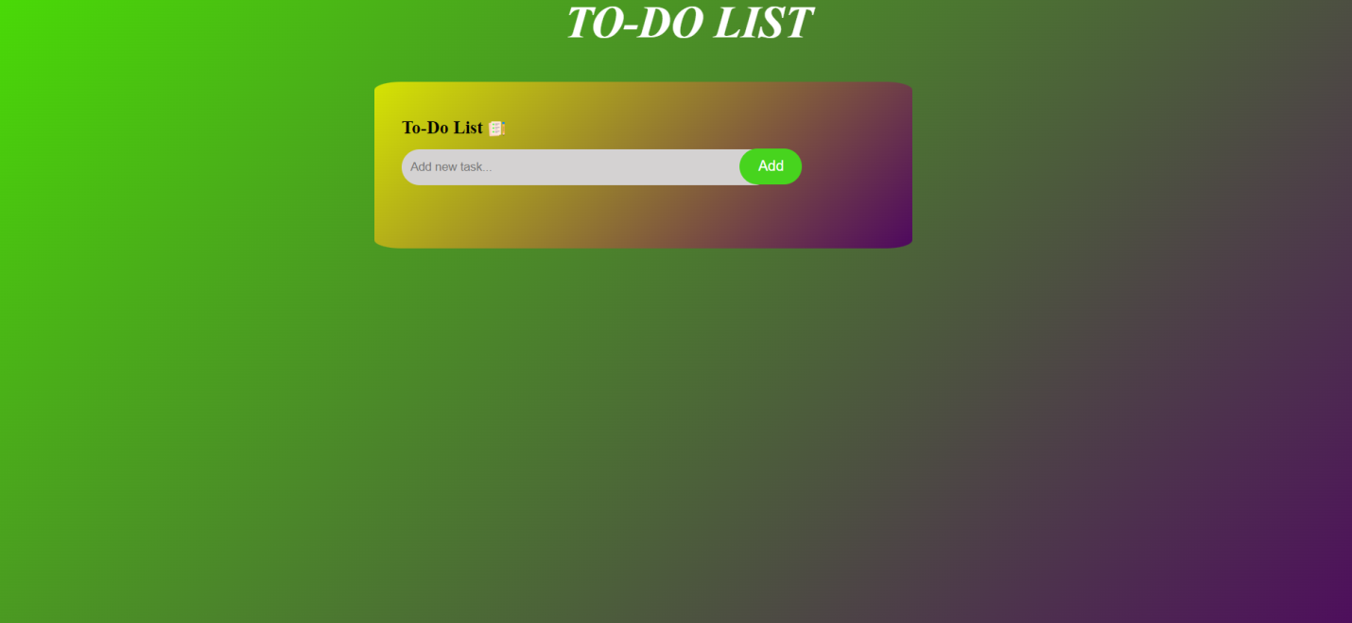

---------------------------------------------------------------------------------------------------------------------

Write the task

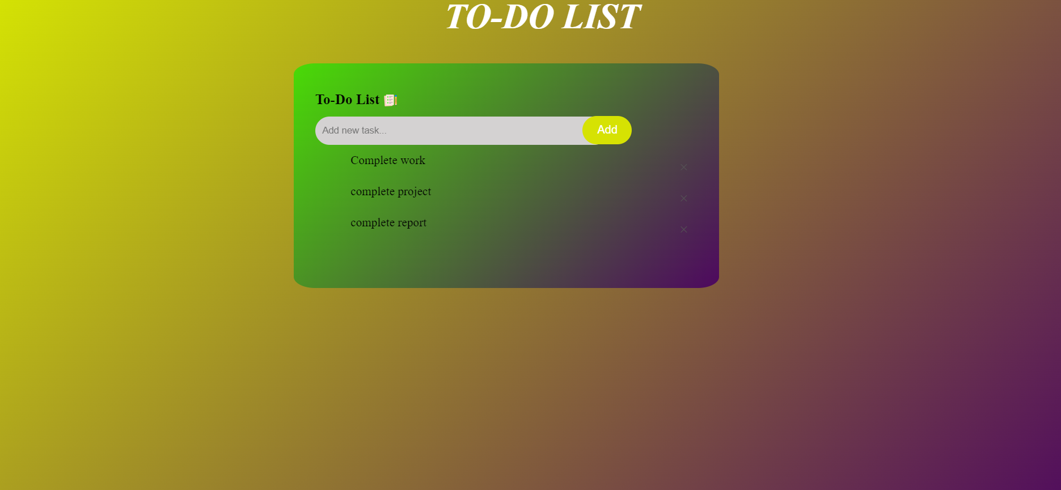

After completing task delete or remove the task

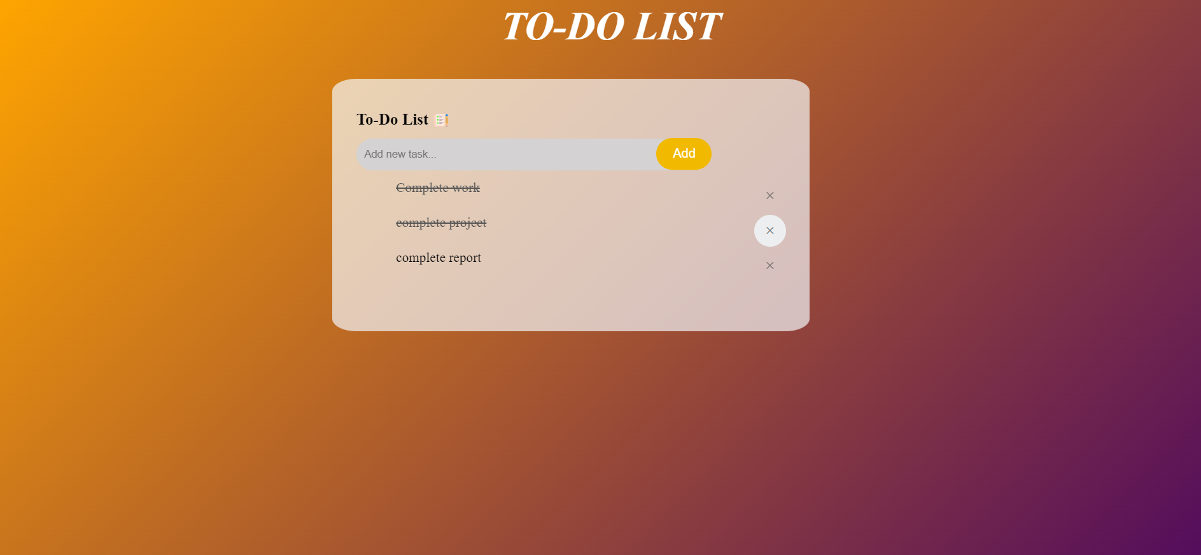----



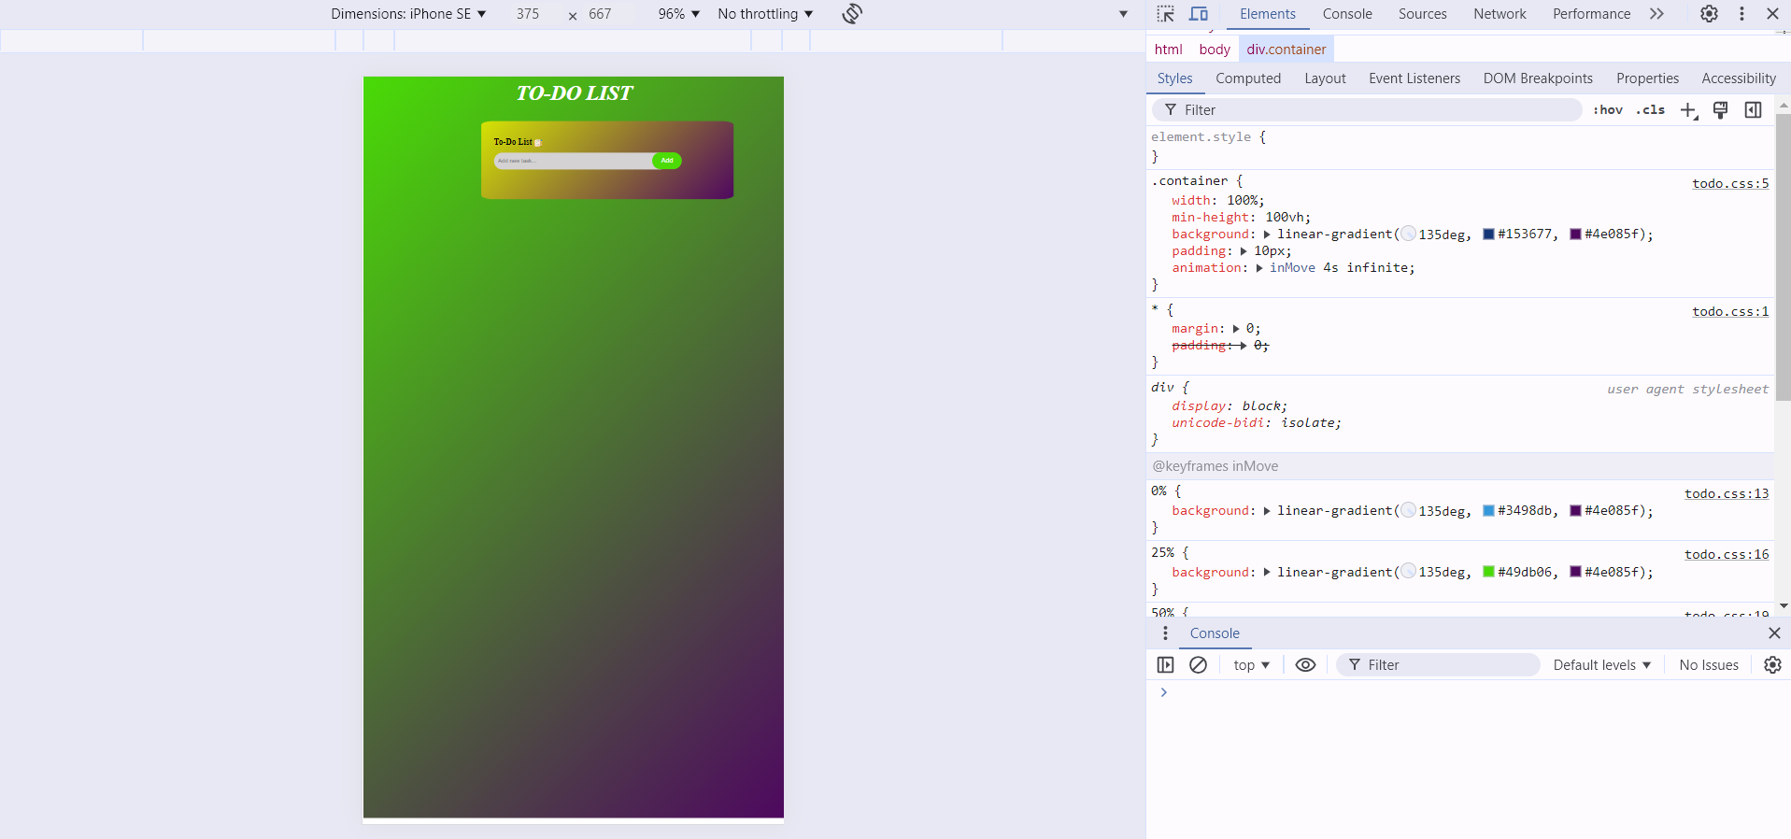

Responsive page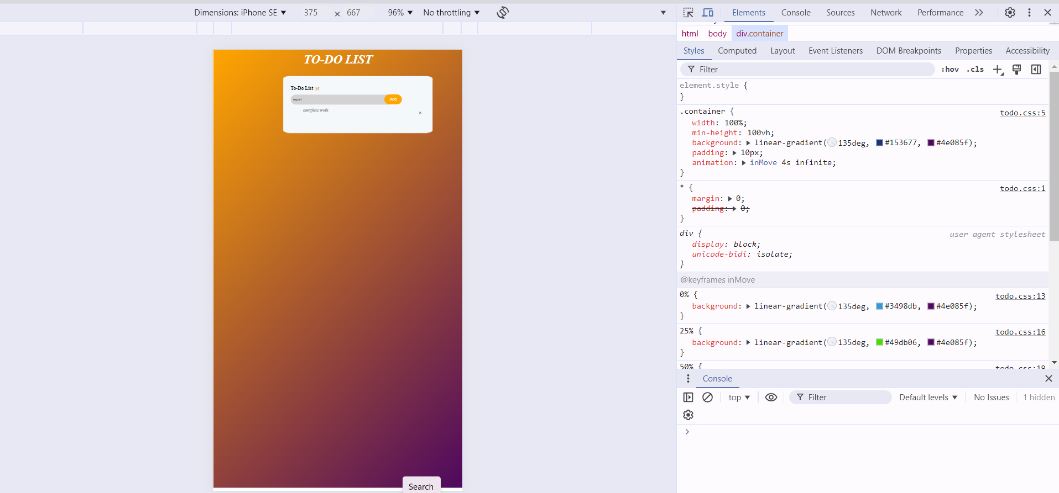

HTML ,CSS ,JAVASCRIPT CODE

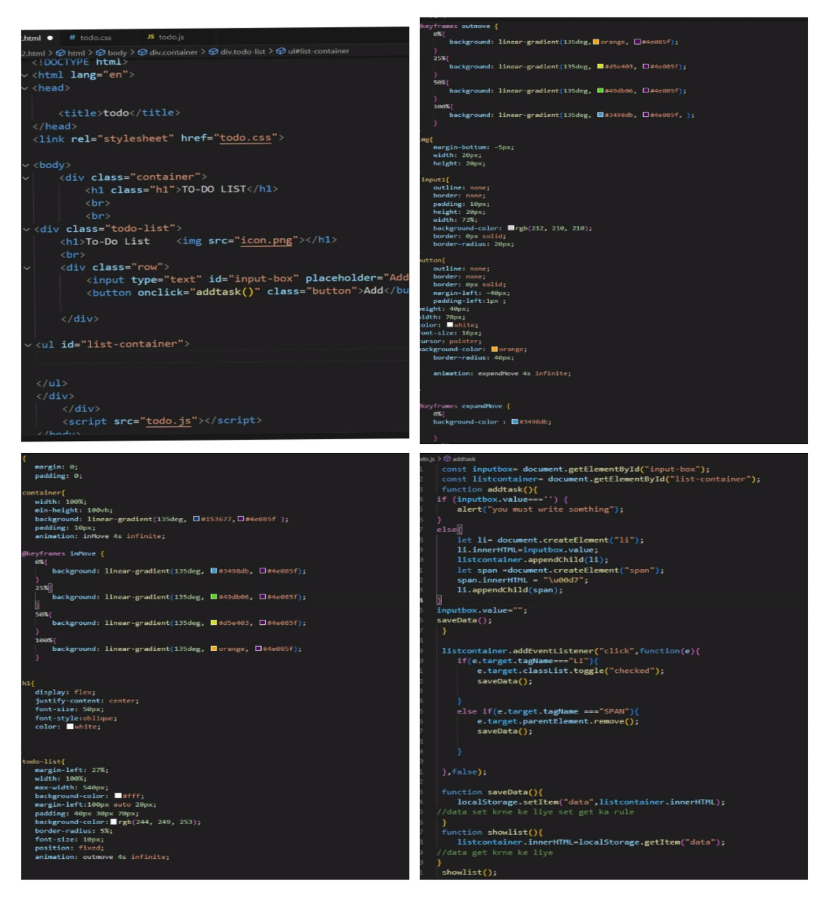

**CHAPTER-5**

**Limitation & Learning Outcomes**

**5.1 Limitations**

1. **Limited Time for Advanced Features**:

The 15-day training period was relatively short, which restricted the depth of exploration into advanced CSS features such as animations, transitions, and CSS Grid. This limited the ability to fully understand and implement more complex styling techniques.

1. **Narrow Scope of Technologies:**

The training was focused exclusively on HTML and CSS, without incorporating JavaScript or other frontend frameworks like React or Angular. This limited the understanding of dynamic web development and interactive user interfaces, which are crucial for modern web applications.

1. **Lack of Real-World Application:**
   1. While the training provided a solid foundation in HTML and CSS, there was limited exposure to real-world scenarios and challenges that web developers face, such as cross-browser compatibility issues, performance optimization, and accessibility considerations.

**5.2 Learning Outcomes**

1. **Proficiency in HTML and CSS:**

Developed a strong understanding of HTML elements and their semantic usage, which is essential for creating well-structured web pages. Gained proficiency in CSS for styling web pages, including the use of selectors, properties, and values to control layout, typography, colors, and more.

1. **Responsive Design Principles:**

Learned the principles of responsive web design, including the use of media queries to create web pages that adapt to different screen sizes and devices. This knowledge is crucial for ensuring that websites provide a good user experience across desktops, tablets, and smartphones.

1. **Basic Project Management:**

Gained experience in managing a small-scale project from start to finish, including planning, designing, coding, and testing. This involved setting goals, meeting deadlines, and documenting progress, which are important skills for any software development project.

1. **Problem-Solving and Debugging:**

Developed problem-solving skills by debugging HTML and CSS code to fix layout issues and styling errors. Learned how to use browser developer tools to inspect and troubleshoot web pages, which is a critical skill for web developers.

1. **Understanding of Web Standards and Best Practices:**

Learned about web standards and best practices for writing clean, maintainable, and accessible code. This includes using semantic HTML, separating content from presentation, and following CSS conventions to ensure that web pages are easy to read and maintain.

**5.3 Some other learnings**

1. **Collaboration and Teamwork:**

Worked collaboratively with peers during the training, which enhanced teamwork and communication skills. This experience is valuable for future projects that require collaboration with designers, developers, and other stakeholders.

1. **Exposure to Industry Practices:**

Gained insights into industry practices and workflows, including the use of version control systems, code reviews, and agile methodologies. This exposure helps in understanding how professional web development teams operate.

1. **Feedback and Iteration:**

Received constructive feedback from mentors and peers, which helped in refining the project and improving coding skills. The iterative process of making changes based on feedback is crucial for continuous improvement.

1. **Time Management:**

Learned to manage time effectively by balancing multiple tasks and meeting project deadline. This skill is essential for handling real-world projects with tight schedules.

**CHAPTER-6**

**Future Scope of the Technology**

The future of frontend web development is promising with the continuous evolution of web technologies. Learning JavaScript and frameworks like React or Angular can further enhance web development skills. Additionally, exploring CSS preprocessors like SASS or LESS can improve efficiency in styling.

**6.1 Analysing the Scope of web Development**

**1. Evolution of JavaScript and Frameworks**

JavaScript continues to be the backbone of frontend development, and its ecosystem is constantly evolving. Frameworks like React, Angular, and Vue.js are becoming more powerful and feature-rich, enabling developers to build complex, high-performance web applications.

**2. Progressive Web Apps (PWAs)**

Progressive Web Apps (PWAs) are gaining traction as they combine the best of web and mobile apps. PWAs offer offline capabilities, push notifications, and fast loading times, providing a native app-like experience on the web.

**3. Single Page Applications (SPAs) and Server-Side Rendering (SSR)**

Single Page Applications (SPAs) provide a seamless user experience by loading content dynamically without refreshing the page. However, SPAs can have SEO and performance issues. To address this, Server-Side Rendering (SSR) and Static Site Generators (SSGs) are becoming popular.

**4. Micro Frontends**

Micro frontends are an architectural style where a web application is divided into smaller, independent fragments that can be developed, tested, and deployed separately. This approach allows teams to work on different parts of an application simultaneously, improving scalability and maintainability.

**5. Artificial Intelligence and Machine Learning**

AI and machine learning are revolutionizing frontend development by automating repetitive tasks and enhancing user experiences. AI-powered tools can assist in design, code generation, and testing, allowing developers to focus on more complex and creative aspects of development.

**6. No-Code/Low-Code Platforms**

No-code and low-code platforms are democratizing web development by enabling non-developers to create functional web applications with minimal coding. These platforms use visual interfaces and pre-built components to simplify the development process.

**7. Enhanced Developer Tools and Workflows**

The future of frontend development will see continued improvements in developer tools and workflows. Tools like Webpack, Parcel, and Vite are streamlining the build process, while TypeScript and ESLint are enhancing code quality through type-checking and linting.

WebAssembly (Wasm) is a binary instruction format that allows code written in languages like C, C++, and Rust to run on the web at near-native speed.

**9. Focus on Performance and Accessibility**

As web applications become more complex, there will be a greater emphasis on performance optimization and accessibility. Techniques like lazy loading, code splitting, and image optimization will be crucial for improving load times and user experience.

**10. Integration with Modern Design Systems**

Modern design systems like Material Design and Fluent Design are providing standardized guidelines and components for building cohesive and visually appealing user interfaces.

**11.Web Components**

Web Components are a set of standards that allow developers to create reusable custom elements, with encapsulated HTML, CSS, and JavaScript. As browsers increasingly support Web Components natively, they are expected to become a core part of the web development ecosystem.

**12.Cross-Platform Development**

The demand for cross-platform development tools like React Native and Flutter is growing. These frameworks allow developers to build applications that run on multiple platforms (web, iOS, Android) with a single codebase, increasing efficiency and reducing development time.

13.**3D Graphics and WebGL**

The use of 3D graphics and technologies like WebGL is expanding, enabling the creation of interactive and visually rich web experiences. This is particularly relevant in industries like gaming, e-commerce, and virtual reality (VR).

14.**Headless CMS and APIs**

Headless Content Management Systems (CMS) and APIs are becoming more prevalent, allowing developers to decouple the frontend from the backend. This provides greater flexibility in how content is delivered and displayed, enabling more dynamic and personalized web experiences.

**15.Augmented Reality (AR) and Virtual Reality (VR)**

AR and VR are making their way into web development, providing immersive experiences directly in the browser. With the evolution of WebXR (Web Extended Reality), developers can create more engaging and interactive applications that leverage AR/VR.

**6.2 Conclusion**

The future of frontend web development is exciting and dynamic, with continuous advancements in technologies and practices. Staying updated with these trends and continuously learning new skills will be essential for developers to remain competitive and deliver cutting-edge web applications.

**REFERENCES**

* MDN Web Docs: HTML and CSS documentation
* W3Schools: HTML and CSS tutorials
* GitHub: Version control and collaboration
* Code with harry
* Apna college